TOWN OF BLUE RIVER OPEN SPACE AND TRAILS PLAN – IMPLEMENTATION STRATEGY

The Blue River Open Space and Trails Master Plan (Master Plan), drafted by the Town of Blue River Open Space and Trails Committee and approved by the Board of Trustees on July 19, 2022, establishes the community vision, goals, and policies for open space and trails throughout the Town of Blue River. Chapter IV. Goals and Policies/Actions and the goals for geographic areas in Chapter VI. Trail Planning Areas of the Master Plan identify specific action items to achieve the vision set forth in the Master Plan. It is understood that the Master Plan is a dynamic undertaking that may take several years to achieve the desired outcomes.

This document “Town of Blue River Open Space and Trails Plan – Implementation Strategy” presents action items in the short term (0-3 years) that will help the Town develop annual budgets and work plans. A number of action items will depend on future staffing levels and capacity, funding, and partnerships. Town of Blue River Staff will work with other public land managers, and other organizations to identify action items that may be conducted collaboratively.

To ensure adaptability in how the Master Plan is implemented, action items and their priority will be reviewed on a regular basis during annual Town budgeting, work plan development, and meetings with staff, the Blue River Open Space and Trails Committee and partners. Action items can be refined, removed, or added as projects are accomplished or priorities change. Annually reviewing action items will also allow Staff and BROSAT to evaluate whether it is meeting the goals of the Master Plan. A more extensive check-in should be completed every five years to evaluate any significant changes or updates to the Master Plan action items. Significant changes could stem from a substantial change in landownership, shifts in demographics, recreation trends, or impacts from climate change or natural disasters.

This document identifies significant tasks considered priority action items for the short-term, next 0-3 years, or actions that are ongoing or completed on an annual basis. to achieve the desired outcome of the goals stated in Master Plan Goals and Policies/Actions and the goals for geographic areas in the Open Space and Trails Planning Areas. (The notation in parentheses that follows an action item refers to the specific trail segment or open space parcel identified in the 7-13-22 Trails and Open Space Inventory Summary-9 worksheets.xlsx and 7-13-22_Open Space and Trails Map-Esmnt&Parcel ID.pdf (available at the Town of Blue River website: https://townofblueriver.colorado.gov/board-of-trustees/commissions/committees/blue-river-open-space-trails-committee.

Master Plan Goal and Policies Actions

- In fall 2022 set up staff level meeting with TOBR, SC, TOB and USFS to review/discuss regulations, and develop cooperative messaging related to TOBR trail/open space objectives (i.e.. neighborhood use).Town of Blue River Staff liaison should be the representative perhaps with the Board Liaison. These tend to be staff level discussions and not the committees.
- Resolve encroachments, trespass, and unauthorized uses within existing dedicated easements, including easements to subdivision landowners as well as easements to the TOBR.-We believe this has been addressed by the Town Attorney and new rules will be addressed in the Land Use Code
- Get on White River National Forest (WRNF) Schedule of Proposed Actions (SOPA) mail list and specifically request notifications on Travel Management Plan (TMP) updates and opportunities to provide comment on USFS projects near Town. (Specifically projects related to the Social Trail along Spruce Creek (LY-9) and Burro Trail access at Bryce Estates (BE-1))?? Is this beyond the work being conducted for fire mitigation?
- Create electronic map of Appendix C in a format similar to other mapping done by Mueller (zoning, land ownership, CIP projects, etc.). Consider hyperlinks on Appendix C map to spreadsheet data for “one stop shopping” of information on open space parcels and potential trail easements shown on Appendix C. -This exists on the website
- Create regular topic in TOBR Newsletter for Open Space and Trails information (e.g., trail etiquette, trailhead parking, Leave No Trace, encroachments in easements, wildlife issues/sightings, etc.).-The Committee has been asked to submit but nothing to date has been provided. Topics should be related to work by the Committee.
- Create an overlay zoning district designating “open space and recreation management zones” for TOBR properties, based on natural, historic, and cultural resources, and outdoor recreation opportunities. Consider amending TOBR Land Use Code/Zoning to include “River Corridor and Open Space Protection Zone”:-This is being discussed in the land use code by the trustees.
  - Include specific high priority parcels identified in Appendix C and described in detail in the spreadsheets.
  - Draft protection criteria, guidelines, and requirements for said zone(s) and start review process with P&Z to codify the new land use zone(s) in current the Land Use Code or amendment thereto.
  - Begin discussions with pertinent landowners to determine interest in working with the Town to grant mutually agreed upon property interests for important open space lands and collaborate with Summit County Safe Passages to protect movement corridors and reduce wildlife-vehicle collisions.-The Committee has been asked to host an open house.
  - Monitor, identify, and treat noxious weed populations on TOBR properties. -This is a project under the Citizen Advisory Committee and there is an existing program “Weed & Seed”.
  - Start dialogue with USFS about special use permit for all NF trails of interest to TOBR (i.e., Blue River Trail) Staff level
  - Work with the USFS to obtain a legal right-of-way granted to the Town of Blue River for the northern portion of Blue River Road that is on National Forest lands. Determine what level of parking should be allowed, designed, signed, and enforced. Consider trail work to create a better entrance to the trail, and similarly access to the Blue River Trail to the east.-This is beyond the scope of the committee and is being addressed with staff and town attorneys.
  - Create new land use code – “Conservation Corridor” for significant segments of Pennsylvania Creek and work through the administrative process to codify this. (PC-1)-The Board of Trustees are developing the land use code.

Planning Area ACTIONS

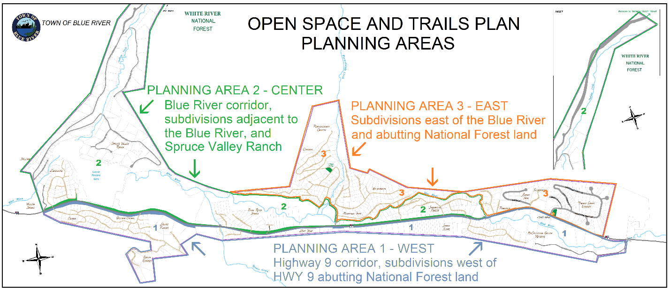

A. Planning Area 1: West -Highway 9 corridor, subdivisions west of Highway 9 and adjacent National Forest land

- Identify and prioritize Open Space parcels that facilitate future Recpath alignment along Hwy 9 ROW and future access to National Forest. (OS-20, 21 & 24). This has been removed as a priority for the Board of Trustees and the Town of Breckenridge. A map with a proposed trail was developed as part of the CDOT Access Plan. It was also stated that this path was not to be a focus for the Trails Committee in 2017.
- Continue pursuing construction of a paved recreational pathway or designated bicycle lane between Hoosier Pass and Breckenridge, with Summit County taking the lead in the planning process. This has been removed as a priority for the Board of Trustees and the Town of Breckenridge. A map with a proposed trail was developed as part of the CDOT Access Plan. It was also stated that this path was not to be a focus for the Trails Committee in 2017.
- Consider having the Town of Blue River formally adopt the segments of the Blue River Trail and Lower McCullough Gulch Trail within and immediately adjacent to Town.

B. Planning Area 2: Center – Blue River corridor, subdivisions immediately adjacent to the Blue River, and Spruce Valley Ranch subdivision

- Partner with like-minded agencies to acquire high priority open space lands, including access to the Blue River Trail in Planning Area 2. (OS-2, 5, 6, 7, 12 & 18)-Staff?
- Work with landowners and USFS to acquire authority to build, use and maintain non-motorized trail ROW across respective parcels from the end of Blue River Road to the Goose Pasture Tarn that allow for single track non-motorized travel. (96-1)-This is currently private land. The landowner has been working with the town with future development plans. The section that crosses USFS land is under review by staff and Town Attorney for solutions.
- Verify TOBR has legal easements and documentation, for the Town records for the Blue River Trail through Spruce Valley Ranch in Planning Area 2. (SVR-1)-This has been verified and is documented on the subdivision map, agreement and with the HOA by staff.
- Work with landowners and owners of Blue River San District easement parcels to acquire authority to build, use and maintain non-motorized trail ROW to tie end of Blue River Road with Blue Rock Springs Sub. (BR-1& BR-2)-This is Theobald land and staff has approached the family for future purchase.
C. Planning Area 3: Planning Area 3- East - Subdivisions East of the Blue River Adjacent to National Forest Lands

- Secure easements across Lot 6 New Eldorado Sub and Lot 18 Aspen View Subs to perfect trail route from end of Vogt easement to Fredonia Gulch Rd. (NE-5)-Staff has completed this and awaiting signed documents.
- Work with landowners on encroachment issues on north end of Audry’s Trail easement (cars parked in easement right-of-way visually discouraging use of trail as well as potential liability issues with damage to cars, tripping on stuff in easement, etc.) (NE-4)-Trustee Dixon address this.
- Work to obtain access easement from Creekside Dr and Hinterland Tr to Pennsylvania Creek (Royal Placer) (W-6 and R-4 & 5)
- Work with USFS on the Old Wagon Road trail that goes from Blue River Road to Coronet Drive to get this on the 2023/24 program of work for heavy maintenance to establish sustainable water diversion features within existing Trail ROW. (96-7)
- Identify significant travel routes, separated from roads where reasonable, that connect the Town Park and Old Wagon Road north of Coronet Drive with the Blue River Trail on Summit County/Town of Breckenridge lands near Pennsylvania Creek, including:
  - Regal Circle near Town Park (Royal Sub, Lot 270 & Lot 271) to the Blue River Trail segment on Town of Breckenridge and Summit County land in the Royal Placer. (R-2)
  - Holly Lane/Bonanza Tr to Pennsylvania Creek (Royal Placer) (C-1 & 2 and OS-14)
  - Coronet Dr to Pennsylvania Creek (Royal Placer) (C-3 and OS-15)
  - North Pennsylvania Creek from Blue River Road to Town Park. (R-1A, 1B, & 1C)
- Cooperate with landowners to secure appropriate right-of-way across lots along the Blue River Trail from Pennsylvania Creek to Calle De Plata, and further south to Timber Creek Estates.
  - High priority – start on north end by securing easements across lots in Sherwood Forest (Lots 82, 83, 88 and 100) up to Clyde Lode. (SF-8)
  - Verify status of “Road Easement” on New Eldorado/Sherwood Forest subdivision plats – Does the TOBR have a legal ROW for the platted road? Plat shows this is dedicated to the Town of Blue River.
  - After establishing credibility in working to secure and manage easements on Calle De Plata-Fredonia segment, approach landowners of Clyde Lode et al concerning easements on Blue River Trail. (W-5)-The owners of the Clyde Lode have stated numerous times they are not interested.
  - Acquire vacant unsubdivided residential land east of Aspen View Sub in unincorporated Summit County (Government Lot 5, TR 7-77 Sec 30, Acres 4.570) to provide re-routing of non-system trail on National Forest that links Fredonia Gulch Road to Timber Creek Estates and 39 Degrees North Sub south of TOBR. (OS-1)-Needs Board direction to staff.
  - Start dialogue with USFS to get the existing non-system trail included in the USFS Travel Management Plan, after Gov Lot 5 has been acquired. (AV-4)
  - Work with Summit County/Town of Breckenridge on the design and construction of an improved parking plan for the trailhead at the end of Coronet Drive and access to Pennsylvania Creek. and develop management plan for Royal Placer and Sherwood Forest Lots. (PC-1) Needs Board direction to staff.
- Work with Summit County/Town of Breckenridge and USFS to evaluate the socially created trail network that is located immediately east of the trailhead at the end of Coronet Drive and north of Pennsylvania Creek and tie this with management plan for Royal Placer and potential forest fuels mitigation planning in 2023. (PC-1) Staff

