Town of Blue River Open Space & Trails Plan

Adopted
December 15, 2020
(Revised May XX, 2022)
(

Table of Contents

- Introduction 3

- Blue River Open Space & Trails Committee 4

- Guiding Principles & Policies 6

- Goals and Policies/Actions 8

- Town Park & Open Space Lands 9

- Trail Planning Areas 11

- Implementation Strategy 15

- Appendices 16
Appendix A: Trail Guidelines 17
Appendix B: Trail Design Standards 18
Appendix C: Master Plan Map (To be Inserted by August 1, 2022)

- Introduction

The Town of Blue River is a small residential community situated in the upper Blue River basin of Summit County, Colorado. The founding fathers of the town, in the 1960’s, envisioned a rural neighborhood community of platted subdivisions with access to many outdoor recreation resources including the Goose Pasture Tarn, Blue River, Pennsylvania Creek and adjoining National Forest, to name a few. The Town recognizes that preserving open space and enhancing trail access through the Town and adjoining upper Blue River Basin is critical to maintaining and enhancing the quality of life in and around Blue River. This Open Space and Trails Plan (Plan) has been created to provide guidance to the Town Trustees for future open space and trail related priorities and decisions. It is recognized that a balance must be achieved between increased recreation use in the Town and the maintenance of a quality neighborhood community life, and that a major focus on the Plan should provide a means for preserving and improving an interconnected recreational trail network and protection of significant open space areas.

This Plan is intended to promote the retention and improvement of a meaningful, well-conceived open space and trail network to preserve and enhance a community amenity for the Town of Blue River residents. The trails outlined in this Plan target non-motorized use, unless otherwise indicated. “Open space” is any open piece of land that is undeveloped (has no buildings or other built structures) and is visible or accessible to the public. This focus is due in part to the Town’s mission to support quiet, sustainable recreational use in a natural, mountain residential community. Many of the trails identified in this Plan connect to trails managed by other jurisdictions, primarily Summit County government and the U.S. Forest Service (USFS). It is recognized that the Town needs to cooperate with these entities to complete the trail system outlined in this Plan.

This Plan is a master plan, which means that it outlines an idealized open space and trail system that inevitably crosses private property. Private property rights are respected and recognized by the Town, and achieving the vision set forth in this Plan will require cooperation from many private landowners both in and out of Town boundaries. The Town has many strategies at its disposal to foster this cooperation, including the development review process, property acquisition, tax incentives and voluntary easement dedication, to name a few.

In the Town of Blue River, residents and visitors stress the importance of a sustainable coexistence with our environment and an interconnected open space and trail system within Town and adjacent public lands. The Town of Blue River Open Space and Trails Plan represents the ideas, both visionary and practical, of Town residents.

- Blue River Open Space and Trails Committee

The Town of Blue River Open Space and Trails Plan is based largely on the efforts of the Town of Blue River Open Space and Trails Committee (Committee). The Committee was established in the fall of 2018 in conjunction with the recommendations of the Town of Blue River Capital Improvement Plan (CIP). After an extensive public involvement process the CIP identified 19 projects for further evaluation and prioritization using criteria developed and agreed upon by the Town Board and its committees. One of the 19 projects was “Develop Trail Network Study”; with two specific tasks: “1) Breckenridge to Blue River/Fairplay Bike Trail Connection – Participate in a planning study to progress the long-term community vision of completing a local bike path from Breckenridge to Blue River and south to Fairplay over Hoosier Pass; and, 2) Developing Town Trail Network – Conduct trail network planning study for trails through Town with connections to existing trails in the Blue River area including the Flume Trail, East trails and trail to Pennsylvania Gulch.” The mission of the Trails Committee is: To assist the Board of Trustees with determining possible trail projects mainly geared towards enhancement of existing trails and possible future trails within the Town of Blue River.

To complete its mission, the Trails Committee reviewed the recorded subdivision plats within the Town of Blue River trails on adjacent National Forest land and known authorized and unauthorized trails and routes used by Town residents and visitors. Over 90 routes were inventoried totaling 9.5 miles.

In the process of inventorying the subdivision plats, it was noted that for many of the recorded subdivision plats “Pedestrian”, “River Access”, “Access Road” and “Private” easements are granted and conveyed “to the owners of the lots thereon” or “to the owners of property in the Town of Blue River“ and not to the Town of Blue River. Because of the way the easements are recorded in the plats, the Town of Blue River, as a governmental entity, may not have the authority for use, occupancy, operation, and maintenance of existing easements within subdivisions. Additionally, some social trails across private lots may have implied historic use that has not legally been granted by the landowner. Therefore, it is recommended that in order to develop a comprehensive trail system using existing, as well as new, rights-of-way that the Town acquire new easements where necessary on designated routes to be identified in a trail system plan.

In January 2020, the Committee held an open house to share their trails vision and gather resident feedback for the future of trails in Blue River. Residents identified the concern for maintaining and acquiring open space lands as an important element to include in a comprehensive trails plan. To address this concern the Committee was tasked with including the identification and evaluation of significant open space lands in its planning efforts. Generally, “Open Space” is any open piece of land that is undeveloped (has no buildings or other built structures) and is visible or accessible to the public.

The Plan will be updated regularly to provide desired recreational experiences for a variety of users while addressing environmental and cultural resources, and general maintenance concerns. Currently, Town of Blue River trails will be limited to non-motorized recreational uses to avoid and minimize user conflicts. In addition to Town staff, volunteer projects will be organized for work in the Town of Blue River. More specifically this document is intended to:

1) Provide a comprehensive plan for public recreational trail network for the Town of Blue River residents.
2) Outline a functioning residential access or commuting trail network that connects efficiently with other modes of transportation (e.g. Town roads, Highway 9, and authorized trailhead parking).
3) Partner proactively with the USFS on the maintenance of existing trails; rehabilitation, restoration, re-routing or abandonment of unsustainable trails; and the development of new trails on National Forest lands surrounding the Town of Blue River.
4) Identify important trail-based recreation opportunities and facilities to enhance recreational opportunities in Town and the surrounding areas.
5) Balance trail use and access within residential communities and important open space lands to minimize negative impacts due to increased recreational uses.
6) Design and implement a wayfinding and signage program that orients trail users to designated trail and open space lands while respecting private lands and is branded and linked with the Town of Blue River.
7) Identify important trail portals and trailheads and access locations to facilitate recreational and commuting uses.
8) Identify important open space lands that are environmentally sensitive and contribute to the Town’s quality of life and rural mountain character.
9) Utilize creative protection techniques to preserve and protect the Town’s significant and threatened open spaces.
10) Provide public access to cultural and geographic landmarks such as the Blue River, Goose Pasture Tarn and Town Park(s).
11) Develop an action implementation schedule that identifies and prioritizes open space and trails projects on an annual basis.
12) Honor and respect private property rights associated with public use on and adjacent to private lands.

This Plan is a targeted document that outlines specific existing and proposed open space and trails resources that the Town would like to secure or create. Broader community goals and directives can be found in the Town of Blue River Comprehensive Master Plan and Capital Improvements Plan, located at https://townofblueriver.colorado.gov/town-plans. Specific trail construction guidelines are found in Appendix B - Trail Design Standards.

Recent Accomplishments
- In 2019, the Blue River Open Space & Trails Committee collaborated with Friends of the Dillon Ranger District to host Blue River’s first Trails Day event. Trail cleanup was conducted off Calle de Plata and a section of the Blue River Trail.
- An easement was obtained off of Calle de Plata connecting to Fredonia Gulch Road as one section of trail connection on the south end of Town.
- In January 2020, the Blue River Open Space & Trails Committee held an open house to share their trails vision and gather resident feedback for the future of trails in Blue River.

- Guiding Principles and Policies

- GUIDING PRINCIPLES
The Blue River Trail System will provide safe connectivity to the surrounding towns and areas. The
trail design will be consistent with the culture of mission of the Town of Blue River and
harmonious with the natural environment. By following approved trail standards and guidelines, keeping constant communication with Town Staff, and using current Forest Service and Summit County trails as an example, the Town of Blue River’s trail system can retain the following important qualities:
- Safe public access
- Minimization of user conflicts
- Sustainability
- Quality construction and maintainability
- Effective signage
- A variety of enjoyable experiences for various user types and skill levels

To ensure that these objectives are achieved, the Town will adopt the Town of Blue River Trail Standards to be used during trail construction and maintenance to provide developers, staff, the public, and trail users with a foundation upon which trail work can be performed.

The Town of Blue River Trail Guidelines (Appendix A) and Trail Design Standards (Appendix B) describe the fundamentals of trail design, trail maintenance standards, trail signage standards, slope stabilization and revegetation, and basic definitions of trail terms. When a trail is conceived or planned in the Town of Blue River, several options are available to obtain legal access to the trail, including easements, land exchanges, purchases, and development agreements.

- TRAIL STANDARDS
A primary goal for the trail system in the Town of Blue River is to assure sustainability of all existing and proposed trail resources. Sustainability on natural surface routes is defined as the characteristic of a travel surface to support currently planned and future uses with minimal impact to the natural systems of the area. Sustainable routes require little rerouting and minimal maintenance over extended time periods. They have minimal soil loss or movement while allowing the naturally occurring adjacent plant systems to inhabit the area. Sustainable routes also minimize negative effects on wildlife and other natural resources. Proper trail alignment, grading and drainage are necessary to create a sustainable trail.

Sustainable trails minimize the need for ongoing trail maintenance by using construction techniques and materials designed for long term self-sustaining use, and by using on-site materials as much as possible. Appropriate design minimizes or eliminates expensive future maintenance and repairs while establishing an enjoyable trail experience for users.

There are specific sustainability standards that apply to different user groups and their impacts. The U.S. Forest Service, Summit County and adjoining Town of Breckenridge have developed and incorporated many of these accepted standards. In order to provide for continuity of design, maintenance and management of trail resources within the Town and adjoining land jurisdictions. These standards will be referred to in the construction and maintenance for all trails in the Town.

Where the protection of environmental (e.g., wetlands, riparian areas, wildlife habitat. etc.) or historic (e.g., mining structures and artifacts) resources is compromised due to unsustainable route alignment or user behavior, these issues will be addressed through custodial maintenance reroutes or closure of the trail resource.

- SIGNAGE
Signs inform trail users of important information about route location, safety considerations, rules/regulations, and education and interpretation. Signs should be carefully designed and installed to inform trail users and avoid “sign pollution,” or an overabundance of signs. Signs should be strategically located, clear, concise, and legible. Signs will be placed at the main trail access points, trail intersections, and other key locations. More heavily traveled routes will be well-signed, while more remote routes will have fewer or no signs to reflect and maintain the backcountry character.

- TRAIL ACCESS PORTALS
Numerous trail portals, intersections of trails and roads, provide access to the trails within the Town. Some portals may have managed parking, (e.g., Blue River Park) whereas many portals do not have parking facilities available. Trail access areas in the Town will be evaluated on an ongoing basis to determine appropriate infrastructure requirements such as the need for designated parking areas, trail information kiosks, signs, benches, or other public facilities. Signs may include bulletin board/kiosk and access portal signs as well as wayfinding signs. All signage will incorporate a uniform design and provide applicable information and regulations. Access portal signs may identify route names or identification label and permissible uses. Where trails provide access to adjoining land management jurisdictions (U.S. Forest Service, Summit County and Town of Breckenridge) consideration will be given contiguity of permissible uses and trail management direction.

- RULES AND REGULATIONS
The successful management of the Town of Blue River trails system depends upon mutual respect among the various user groups, and communal respect for the invaluable environmental and cultural resources being protected for the benefit of all current and future residents and visitors. The adjacent trail resources in Summit County and the Town of Breckenridge are governed by the Rules and Regulations for County Open Space Properties reviewed by the Breckenridge Town Council and adopted by the Board of County Commissioners in 2007 and as amended. The Forest Service rules and regulations and area-specific Forest Supervisor Orders apply on the National Forest Lands. It is recommended that the Town of Blue River incorporate these two sets of regulations to create consistent and enforceable rules for its trails and across jurisdictional boundaries.

A person may ride a Class 1 or Class 2 electric assisted bicycle on the paved portions of the Town of Blue River trail system and on the roads within Town. “Class 1 electric assisted bicycle” means an electrical assisted bicycle equipped with a motor that provides assistance only when the rider is pedaling and that ceases to provide assistance when the bicycle reaches a speed of twenty miles per hour. “Class 2 electric assisted bicycle” means an electrical assisted bicycle equipped with a motor that provides assistance regardless of whether the rider is pedaling but ceases to provide assistance when the bicycle reaches a speed of twenty miles per hour.

Trail user education is preferred as the most efficient method of obtaining compliance to regulations.

IV. Goals and Policies/Actions

Goal A. Develop, maintain and improve trail access and quality recreation opportunities.
- Policy/Action 1. Provide diverse year-round non-motorized trail recreation opportunities.
- Policy/Action 2. Identify and manage trails that provide appropriate recreational experiences while protecting the area’s natural and historic resources as well as minimizing user conflicts.
- Policy/Action 3. Secure easements, property interest, or other agreements and authorizations to retain and enhance public recreational access to existing and proposed routes and trailheads.
- Policy/Action 4. Design and build trail portals to address desired trail uses, volume of use and the long- and short-term capacity of the resource.

Goal B. Plan and provide for the sustainable maintenance of trails and trail portals.
- Policy/Action 1. Close and restore user created routes that are not part of the identified travel system.
- Policy/Action 2. Use trail design and construction standards that incorporate sustainability guidelines.

Goal C. Manage the travel system in cooperation with other public and private entities.
- Policy/Action 1. Create and expand public/private partnerships, including “Adopt-a-Trail” programs.
- Policy/Action 2. Work to minimize existing and potential conflicts between
property owners and recreational users.

Goal D. Provide public information to promote stewardship and appropriate recreational use.
- Policy/Action 1. Install signage at trailheads/portals with appropriate information.
- Policy/Action 2. Post pertinent information to encourage sustainable resource use and facilitate law enforcement.
- Policy/Action 3. Continue to work cooperatively to make Town regulations consistent and enforceable across jurisdictional boundaries, including USFS Supervisor’s Order or other mechanisms.
- Policy/Action 4. Provide accurate information about trails and access points to social media and publishers of trail guides and maps.

Goal E. Develop, maintain and improve travel signage.
- Policy/Action 1. Provide uniform signage to direct users to appropriate recreational opportunities.
- Policy/Action 2. Incorporate Leave No Trace and Tread Lightly messages on signs to educate users on rules and codes of conduct.
- Policy/Action 3. Install directional signage at trail intersections identifying routes and allowed uses.

Goal F. Identify, acquire, and protect environmentally sensitive areas to preserve and maintain unique natural areas, wetland and wildlife habitat, the rural mountain character, and access to present and future recreation opportunities.
- Policy/Action 1. Identify and evaluate undeveloped lands in order to decide which areas should be recommended to be protected and managed as open space.
- Policy/Action 2. Identify specific properties and acquire property interests, when zoning and development regulations are not a viable alternative, to protect and enhance the recreational trail network within the Town.
- Policy/Action 3. Acquire property interests to protect the Blue River corridor and the scenic backdrop visible along Highway 9 through the Town when land use regulations are not a viable alternative.
- Policy/Action 4. Secure easements, property interest, or other agreements and authorizations to preserve the natural open space character of the Goose Pasture Tarn and surrounding undeveloped lands.
- Policy/Action 5. Prepare site specific open space protection management reports for acquired open space parcels that identifies strategies to be implemented to protect the open space qualities of the parcel.

V. Town Park and Open Space Lands

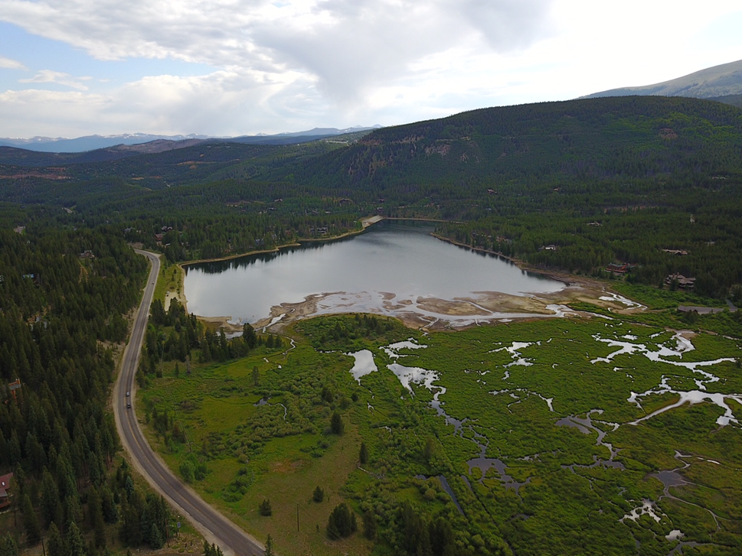
Photo credit: James Quigley, Louise Placer

- TOWN PARK
In, 2012 with the assistance of a grant from the Greater Outdoors Colorado fund, and a land donation from the Theobald Family, the Town of Blue constructed the Robert A. Theobald Memorial Park. The park was designed with the Town’s natural environment in mind. It includes several youth playground features, a small trail system and interpretive signs to provide education of the natural features found within the park. The Town and Open Space & Trails Committee will continue to enhance features and activities for families and visitors to Town.

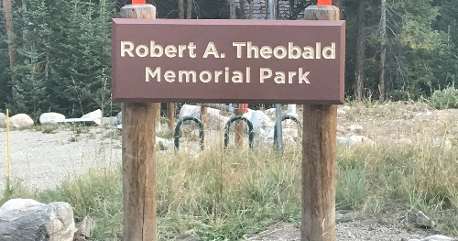

- OPEN SPACE LANDS
The Town of Blue River and the Blue River Open Space & Trails Committee seeks to preserve and enhance the serene mountain environment within the Town of Blue River. With this mission in mind, it is desired, when possible, to acquire land for this purpose. Open space land is any open piece of land that is undeveloped (has no buildings or other built structures) and is visible or accessible to the residents and visitors in the Town of Blue River.

The Town of Blue River owns several parcels of land that are protected and managed to preserve and maintain wildlife habitat, the rural mountain character, unique natural areas and high quality of life for all. Current areas include Town owned land south of the Goose Pasture Tarn, wetland areas in the Timberline Subdivision and New Eldorado Subdivision.

This Plan recognizes the importance of living with wildlife and preserving environmentally sensitive areas and encourages utilizing creative protection techniques to preserve and protect the Town’s significant and threatened open spaces. The Open Space and Trails Plan focuses on lands that most contribute to the Town’s quality of life and rural mountain character, including those with the following characteristics, in no particular order:

Access: Lands that provide trailheads or public access to recreation areas on National Forest and other significant properties.

Buffers: Natural and undeveloped lands which separate and buffer the impacts of development, define the boundaries of urbanized areas, and contribute to the rural mountain quality of the Town.

Extensions: Land adjacent to publicly held property which meets open space criteria guidelines, and which can combine with other open space properties to enlarge and / or connect existing open space parcels.

Recreational: Lands with significant recreational value, particularly non-motorized passive uses not requiring intensive maintenance or management; including lands or easements providing for public use of existing and proposed trails.

Unique Lands: Lands possessing unique values such as outstanding (but not necessarily generally visible) scenic quality, rare flora, riparian quality, wetlands, critical wildlife habitat, fragile alpine areas, or unusual geologic, or topographical formations.

View Corridors: Lands with high aesthetic appeal and variety within major view sheds, whose lands are generally visible, apparent, and appreciated by residents and visitors and through preservation will maintain the rural mountain appearance of Summit County.

The Committee recognizes that one of the challenges when protecting open space lands is finding the most appropriate methods of protection. It is important to satisfy both the Town’s desire to protect land for open space values and landowners’ desires for use of their property. Due to the limited financial resources available for direct purchase of open space lands, and the current market value of property within the Town of Blue River, it is not feasible for the Town to purchase every desirable open space parcel. It is therefore critical to use a variety of protection/acquisition measures and allow open space funds to be spent in the most cost-effective manner. The recommended approaches to land protection include partnerships with likeminded organizations, conservation easements, regulatory techniques, potential transfer of development rights, access easements, land exchanges and fee simple ownership. These and other measures will be explored on a case-by-case basis as significant open space lands are identified and determined to be suitable for further analysis.

- Trail Planning Areas

The scope for this Plan includes the entire Town of Blue River and where appropriate adjacent lands outside the town limits. To better describe the various trails and routes in the area, the Plan is divided into three planning areas within and around the Town of Blue River (see Figure 1 “Planning Area Vicinity Map”) including:

Planning Area 1 -West – Highway 9 corridor, subdivisions west of Highway 9 and adjacent National Forest land.

Planning Area 2 - Center – Blue River corridor, subdivisions immediately adjacent to the Blue River, and Spruce Valley Ranch subdivision.

Planning Area 3 – East – subdivisions east of the Blue River and abutting National Forest lands.

Along with goals and objectives for the entire Open Space and Trails Plan, noted in the previous section of this document, there are specific goals and recommendations for each planning area. The specific recommendations reflect actions that can be taken to achieve that planning area’s goals.

Figure 1. Planning Area Vicinity Map
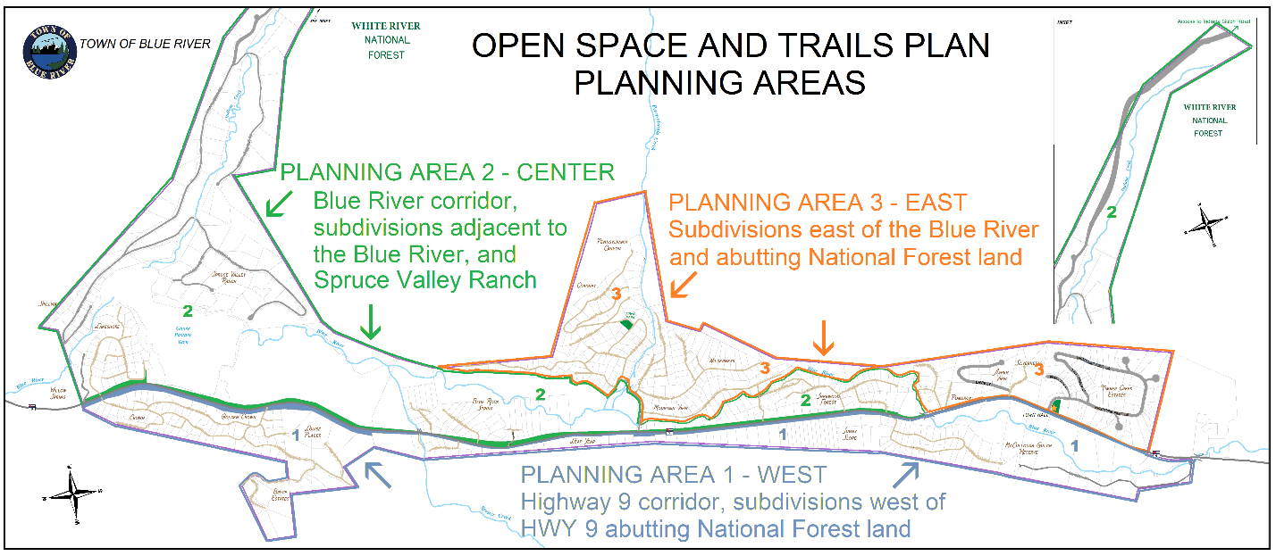

- Planning Area 1: West -Highway 9 corridor, subdivisions west of Highway 9 and adjacent National Forest land
Planning Area 1 encompasses residential subdivisions within Town limits west of Highway 9. The subdivisions include Crown, Bryce Estates, Leap Year, Sunnyslope, 97 Circle, and McCullough Reserve, and Timber Valley subdivisions. There are two trailheads outside the Town limits of Blue River including the USFS Spruce Creek Trailhead and Lower McCullough Gulch Trailhead.

Goals for Planning Area 1
  - The Blue River corridor at the southern end of the planning area is relatively undisturbed and is an important wildlife/waterfowl area. Do not encourage use nor future trail development along the river corridor in this area.
  - Work cooperatively with Summit County, USFS and McCullough Gulch Reserve to maintain the trail connection from Rio Azul Road to the Lower McCullough Gulch Trail on National Forest land.
  - Continue to work cooperatively with CDOT, the Town of Breckenridge, Summit County, the USFS and other partners to complete a grade-separated recpath from the junction of Boreas Pass Road and Highway 9 to Hoosier Pass.
  - With the exception of the Lower McCullough Gulch Trail there are no designated trails on National Forest lands west of Hwy 9 and immediately adjacent to the Town of Blue River. Work cooperatively with the USFS on any updates to the White River National Forest travel management plan that may propose new trails in the future.
  - Identify significant travel routes, separated from roads where reasonable, within subdivisions that allow for single-track non-motorized travel to connect subdivisions and provide access to established trails and open space/parks.
  - Work cooperatively with the USFS to identify, for future construction, potential non-motorized single-track routes to connect travel routes in the Town with the Spruce Creek Trail and Burro Trail on National Forest land.

- Planning Area 2: Center – Blue River corridor, subdivisions immediately adjacent to the Blue River, and Spruce Valley Ranch subdivision,
Planning Area 2 encompasses land within Blue River town limits, and residential neighborhoods immediately adjacent to and nearby the Goose Pasture Tarn and Blue River, including, Spillway and Rivershore, Blue Rock Springs, Spruce Valley Ranch, ’96 (western portion), Mountain View (west of Mountain View Road), Sherwood Forest, and New Eldorado (abutting the Blue River) subdivisions. Currently, there are no formal trailheads inside the Town of Blue River in the planning area. At the north end of Blue River Road, on National Forest land, is an informal parking area to access the Blue River Trail and social trail along the Blue River.

Goals for Planning Area 2
- The Blue River corridor and Goose Pasture Tarn is a relatively undisturbed wetland/riparian complex through the planning area and is important wildlife/waterfowl habitat. Do not encourage use nor future trail development along the river corridor in this area.
- The terrain is very steep on eastern portion of the river in the Planning Area, making it difficult to build sustainable trails.
- Wayfinding/signage is needed in the area on a site-specific basis in cooperation with landowners.
- Work cooperatively with landowners to consider putting undevelopable land along the Blue River in conservation easement status.
- Identify and explore easements for significant travel routes, separated from roads where reasonable, from the end of Blue River Road to the Goose Pasture Tarn that allow for single track non-motorized travel.
- Maintain public access along the Blue River Trail from the Town of Blue River to Breckenridge along established easements in Spruce Valley Ranch subdivision.
- Identify significant travel routes, separated from roads where reasonable, within Blue Rock Springs subdivision that allow for single-track, non-motorized travel to connect subdivisions and provide access to established trails and open space/parks.
- Work with the USFS to obtain a legal right-of-way granted to the Town of Blue River for the northern portion of Blue River Road that is located on National Forest lands.

- Planning Area 3- East - Subdivisions East of the Blue River Adjacent to National Forest Lands
Planning Area 3 encompasses land within Blue River town limits, and residential neighborhoods east of the Blue River up to and abutting the National Forest; including, ’96 (eastern portion), Mountain View (east of Mountain View Road), Wilderness, Royal, Coronet, New Eldorado (east of Blue River), Aspen View and Timber Creek Estates subdivisions. There is a formal trailhead on land owned by Summit County and the Town of Breckenridge, known as the “Royal Placer” at the end of the Coronet Drive for 4-6 cars.

Goals for Planning Area 3
- Identify and explore easements for significant travel routes, separated from roads where reasonable, from the end of Calle De Plata to the Fredonia Gulch Road that allow for single track non-motorized travel and provide access to established Forest Service trails and roads.
- The Pennsylvania Creek corridor itself is a relatively undisturbed wetland/riparian complex through the central portion of the planning area and is important wildlife habitat. This must be considered in planning, design, and construction of any trails along the creek.
- Work with USFS on the Old Wagon Road trail that goes from Blue River Road to Coronet Drive to re-route trail to meet sustainability standards for mountain bike use and connect to Blue River Trail Extension at Royal Placer, via Coronet Drive and Holly Lane.
- Wayfinding/signage is needed in the area on a site-specific basis after coordination with landowners affected by the proposed improvements.
- Identify significant travel routes, separated from roads where reasonable, that connect the Town Park and Old Wagon Road north of Coronet Drive with the Blue River Trail on Summit County/Town of Breckenridge lands near Pennsylvania Creek.
- Cooperate with landowners to secure appropriate right-of-way across lots along the Blue River Trail from Pennsylvania Creek to Calle De Plata.
- Work with Summit County/Town of Breckenridge on the design and construction of an improved parking plan for the trailhead at the end of Coronet Drive and access to Pennsylvania Creek.
- Work with Summit County/Town of Breckenridge and USFS to evaluate the socially created trail network that is located immediately east of the trailhead at the end of Coronet Drive and north of Pennsylvania Creek.

- Implementation Strategy

2 to 5 year Planning Period

Focus on securing a legal and sustainable route along the Blue River Trail (FDT606.1) corridor in Planning Area 3. Several trail segments need further work in obtaining easements, as well as access from Regal Circle near Town Park to the Blue River Trail segment on Town of Breckenridge and Summit County land in the Royal Placer. Continue to Identify and explore acquiring easements for significant travel routes, separated from roads where reasonable, between and within subdivision that allow for single track non-motorized travel and provide access to established trails and open space/parks within Town and onto National Forest lands.

Inventory and evaluate significant and threatened open space lands for protection of wildlife habitat and preserving environmentally sensitive areas. Partner with like-minded agencies to acquire high priority open space lands, including access to the Blue River Trail in Planning Area 2.

3 to 5 year Planning Period

Evaluate open space lands in Planning Area 2 that might be considered for conservation of the river corridor with the understanding that residents might access this area for fishing and enjoying the natural environment. Some more immediate consideration might be given to extending a pathway for multi-modal transportation access for residents in Blue Rock Springs Subdivision to access the Blue River Road. These residents would benefit from a pedestrian easement along Hwy 9 on private property to access the Summit Stage and/or the local trail network being developed along the Blue River Trail. Public outreach to determine willingness to participate in the Town's trail easement "donation program" should be investigated in the near term.

5+ year Planning Period

Planning Area 1 includes Highway 9 and the general alignment of the proposed future Hoosier Pass Rec Path. Residents on both sides of the highway would benefit from safe passage across Hwy 9 to access existing and future trail routes. Future discussions are needed as the Town does not have control over Hwy 9 speed limits or cross walks.

- Appendices

Appendix A - Trail Guidelines
Appendix B – Trail Design Standards
Appendix C – Open Space and Trails Master Plan Map (To be Inserted by August 1, 2022)
Appendix A - Trail Guidelines

Guidelines for Trail Design
Where new trails are constructed on provided easements, substantial altering of the existing grade of the property will be prohibited. The new trails and will be required to be consistent with the existing topography. Trails will be designed to minimize impact on the natural environment and will be designed according to Appendix B – Trail Design Standards.

A. Sustainability
Trails that require little rerouting and minimal maintenance over extended periods of time and can support currently planned and future uses with minimal impact to the natural systems of the area are considered sustainable. Proper trail alignment, grading and drainage are necessary components of a sustainable trail.

Characteristics of a Sustainable Trail
• Connects selected control points
• Gets water efficiently off the trail
• Offers different experiences for various users with differing ability levels
• Encourages users to stay on the trail
• Follows natural contours
• Grade follows The Half Rule (Grade does not exceed half the side-slope)

Characteristics of an Unsustainable Trail
• Results in significant tread incision and gullying
• Results in severe erosion or washout
• Contains multiple or braided treads
• Impacts private property
• Causes sedimentation in nearby watercourses

B. Design Objectives
The Blue River Trail System will provide safe connectivity to the sounding towns and areas. The trail design will be consistent with the culture of mission of the Town of Blue River and harmonious with the natural environment.
- Safety will be the top priority. Where possible, trails will remain off major roads and avoid use of Highway 9.
- The trails will be use by hikers, bicyclists, horses and skiers of varying abilities. Access for the physically handicapped will be provided, whenever possible.
- Design will be conducted to minimize impacts on the natural environment.
- The design will be sensitive to the area’s preservation/restoration.
- Trails will provide connectivity through Town connecting to the Forest Service and Town of Blue River trails.
- Trails will be for year-round use. Limitations may be put into place during “mud” seasons to limit damage and erosion.
- A detailed trail vision map will be created and referenced when determining connections. Alternatives will be explored where necessary.
- Trails shall be designed to minimize future maintenance.
- When possible, trails should be planned, designed, and constructed to match trail standards with the U.S. Forest Service.
- Signage shall be conforming to U.S Forest Service standards. Signage shall be provided when entering private property restricting access to the trail.
- Trails will not be maintained in the winter.

C. Trail Alignment
- Trails should consider comfort, safety, enjoyment, minimal maintenance, environmental impacts for year-round use. Where possible trails should be constructed with a grade of 10% or less within the Town of Blue River.
- Trails should consider sight distances, noting narrow sections, intersections, hills and curves.
- Trails should, where possible, follow the natural terrain minimizing the need for cuts into hillsides and erosion.
- Trails should minimize the impacts to the adjacent natural environment, wildlife habitat and avoid wetland areas.
- Bridges shall be constructed with natural materials and be sustainable minimizing maintenance needs.
- Alignment should be located away from tree trunks and at the edge of heavily wooded areas to minimize vegetative clearing and tread damage from roots.
- Easements shall be placed according to owner’s wishes to minimize impacts to individual lots.

Appendix B – Trail Design Standards

Table of Contents
Acknowledgments
I. Town of Blue River Trails
II. Trail Design Standards
A. Trail Corridor
1. Trail Prism
2. Sightlines
3. Adjacent Slopes
4. Width
B. Trail Tread
1. Grade
2. Half Rule
3. Out Slope
4. Switchbacks and Curves
C. Drainage
1. Grade Breaks
2. Drainage Dips
3. Water Bars
4. Armoring
5. Culverts
6. Swale Crossings
7. Side Swales
8. Crowning
III. Other Trail Considerations
A. Environmentally Sensitive and Hazardous Areas
B. Winter Trails
C. Existing Trails
D. Trails with Universal Access
E. Wetlands and Water Crossing
F. Slope Stabilization and Revegetation
G. Structures
1. Retaining Walls
2. Bridges
3. Boardwalks
4. Turnpikes
5. Fences
6. Steps or Stairs
7. Railings
H. Trailheads and Signage
I. Intersections
J. Trail Designation
1. Hard Surface
2. Soft Surface
3. Natural

Acknowledgements

Much of the information in this document is a reproduction of material from the Town of Breckenridge Trail Standards and Guidelines (2007), which is a compilation of material from trail’s plans in other mountain communities such a Trails Design and Management Handbook from the OpenSpace and Trails Program in Pitkin County and Eagle County, Park City (Utah), and the City of Aspen’s trail’s manuals. Illustrations in this document are provided courtesy of the International Mountain Biking Association.

National Standards from the National Park Service, the USDA Forest Service, Colorado Department of Transportation, and the American Association of State Highway and Transportation Officials were also reviewed and when applicable, were incorporated into this document.

I. Town of Blue River Trails
In the Town of Blue River residents and visitors stress the importance of a sustainable coexistence with our environment and an interconnected trail system within Town and adjacent public lands. By following the guidelines set forth herein and using current trails in Town and in Summit County as examples, the Town of Blue River’s trail system can retain the following important qualities:
• Safe public access
• Minimization of user conflicts
• Sustainability
• Quality construction and maintainability
• Effective signage
• A variety of enjoyable experiences for various user types and skill levels

To ensure that these objectives are achieved, the Town of Blue River Trail Standards shall be used during trail construction and maintenance to provide developers, staff, the public, and trail users with a foundation upon which trail work can be performed. Also included in this document are the fundamentals of trail design, trail maintenance standards, trail signage standards, slope stabilization and revegetation, and basic definitions of trail terms.

When a trail is conceived or planned in the Town of Blue River, several options are available to obtain legal access to the trail, including easements, land exchanges, fee simple purchase, development agreements and condemnation.

II. Trail Design Standards

A. Trail Corridor
The trail corridor is the cleared area above and on either side of the tread needed to accommodate the trail and its users. It varies in size depending on the type of trail and trail use and requires clearing and limbing, grading of adjacent slopes, drainage structures, and revegetation.

1. Trail Prism
The trail prism is the cleared area necessary for safe use of the trail. To create the prism, an opening needs to be cleared through trees and shrubs. Tree trunks, projecting rock ledges, limbs, logs and brush should be removed for a minimum distance on both sides of the tread and a minimum height above the trail. The exact distances for the vertical and horizontal clearance will be vary based on a trail type, width, use, etc. The opening created by this clearing should not be apparent to users, hence vegetation should be pruned selectively and irregularly to make the prism look as natural as possible. Do not disturb the natural environment outside of the trail corridor. When small trees and bushes are within the tread, do not cut them flush with the ground. Dig them out, including the roots, to avoid future
erosion around them that would cause greater trail damage. When trimming branches do not cut the branch flush with the trunk. Leaving a branch nub will help the cut heal more quickly. Place felled trees and cut branches at least 10 feet from the corridor with the cut end pointing away from the trail.

A trail corridor should be at least twice as wide as the tread width. This can vary with terrain and the type of user the trail is designated. Vertical and horizontal clearance standards are located within the standards and guidelines for trail types (see Section III. J.).

2. Sightlines
To reduce the potential for collisions or accidents, the trail user should be able to safely and clearly observe the trail ahead and upcoming intersections or obstacles. When determining sightline, the speed of the trail user will lengthen or shorten the distance required for proper reaction time to occur. In conjunction with sightline, grade should be considered. When possible, curves, stops and reduced speed zones should be on a flat grade with an adequate sightline. If a curve is required on a grade, a longer sightline should be designed. When sightlines cannot be an adequate length, a slow sign should be considered.

Sightlines
Design Speed | Sight Distance
20 mph | 130-200’
15 mph | 85-130’
10 mph | 35-60’

Above are some guidelines to use when determining sight distance, exceptions may be required for certain sections of trails.

3. Adjacent Slopes
Ideally, all trails would be constructed using full-bench construction techniques (see illustration). The process of removing soil from one area and placing it somewhere else to form a base for any given activity is called cut and fill. To create a more uniform trail, this technique is recommended over hauling in material from an outside location, although both are less preferable than full bench construction. Any cut and fill slopes adjacent to the tread should not exceed two horizontal to one vertical unless Town staff determines soils are of qualities that justify the stability of a steeper slope. On slopes above 30%, retaining measure (e.g. walls) may be necessary to avoid excessive disturbance created by extreme cut and fill slopes. Most cut and fill slopes should be revegetated. (See the "slope stabilization, revegetation and landscaping" and "retaining walls" sections for details on dealing with adjacent slopes.)

4. Width
The width of the tread will vary depending on the type of trail, type of user, number of users and steepness of slope being traversed. Generally, equestrians require wider treads than hikers and mountain bikers. On steeper slopes (generally 30% or greater), construction at the minimum tread width may be necessary to reduce the impact of cut and fill slopes and construction costs. For wheelchair use, 5-foot tread width will allow two wheelchairs to pass one other. Width standards are located within the standards and guidelines for trail types.
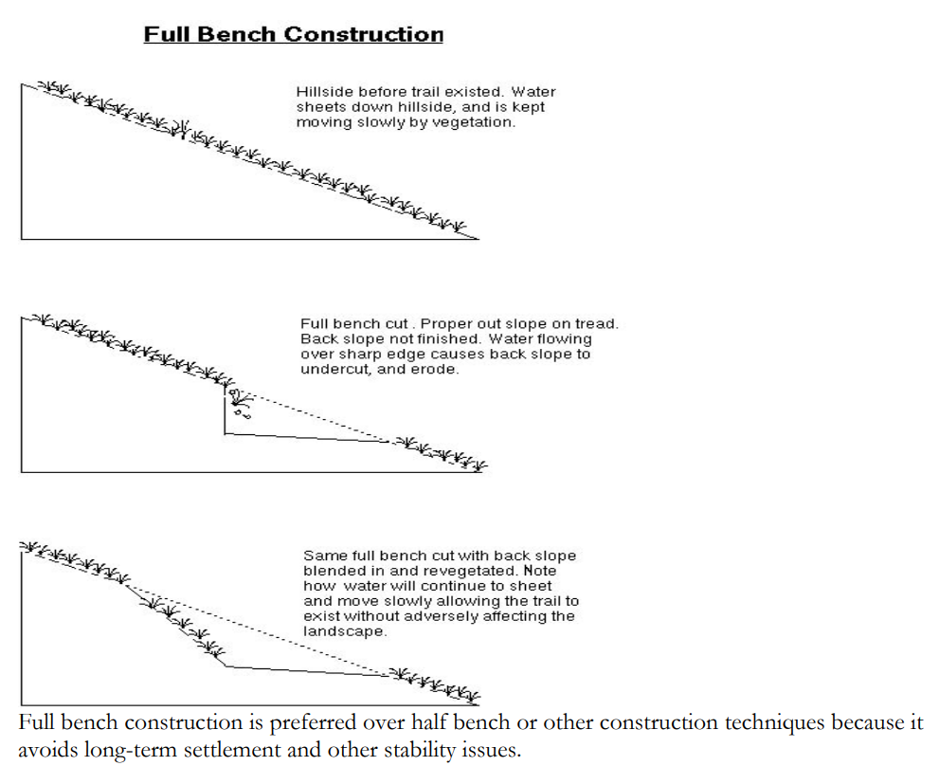

D. Trail Tread
When most people visualize a trail, they think only of the actual surface portion of the trail on which users travel- also known as the trail tread. The following are important considerations when considering how to design and construct the trail tread:

1. Grade
The proper grading on a trail is essential for maximum use and minimum maintenance. A grade that is too steep may deter trail use and will provide an easy path for water to flow. An increase in water on the trail creates an opportunity for erosion and trail damage.

Grade is determined with the formula rise/run x 100 (e.g., Rise=2’; Run=20’; Grade=2/20 x 100=10%). In general, a 10% average or less for the entire trail is the most sustainable.

Details on grade are located within the standards and guidelines for trail types. However, some general guidelines when determining trail grade include:
• When trying to gain a lot of elevation, use shorter, steeper gradients broken up by
more gradual (resting) sections of trail as opposed to long even gradients, which are
more tiring to the user and tend to collect and carry water. If a sustained elevation gain
is necessary, (i.e., over 200 feet), every effort should be made to keep it below 6% for
hard surface pathways and soft surface trails and 8% for natural and rough trails. Use
the chart below for more guidelines on the size if the grade for the length of trail.
• Where shorter, steeper grades are used to break up a long, sustained pitch, it should be
recognized that soft surface, natural, and rough trails with grades above 10% are more
prone to erosion, especially when they exceed 15%. Maintenance and sustainability of
these trail types are easiest when grades are below 10%.
• Avoid the fall line. A trail along the fall line will become an easy path for water to flow
creating significant environmental damage from erosion.
• Where possible, avoid trails constructed in flat topography as they do not facilitate
effective drainage and present the possibility for the trail to retain water.
• Climbing turns and switchbacks are curves in the trail that reverse the direction of
travel. They may be needed to reduce grade when gaining elevation. Climbing turns are
wide, ascending curves that work only on gentle to medium slopes of less than 20%.
They are preferred over switchbacks because they are easier to construct and use. A
switchback is a sharp, short radius curve that should be used as a last resort on hillsides
where the working area is limited and slopes are greater than 20%. Switchbacks are
difficult to construct, require continual maintenance, do not always accommodate
mountain bikes, and are a challenge to manage because users may shortcut the turn.

This chart provides some guidelines to use when determine the length of the trail on certain grades, exceptions may be required for certain sections of trails.

Trail Length Limits on Grades

Grade | Limit on Length at that grade
<3% | None
5+ to 6% | 700’
6+ to 7% | 400’
7+ to 8% | 200’
8+ to 9% | 100’
9+ to 10% | 50’
10+ to 15% | 25’
15%+ | 0’

2. The Half Rule
The half rule is a common rule of thumb when determining proper grade. To ensure proper drainage, a trail’s tread grade should not exceed half of the grade of the hillside or side slope that the trail is traversing. If the trail is more than half of the side slope, it is a fall–line trail. In this case water will flow down the trail as opposed to sheet across it. For example, a trail passing through an area with a gentle 6% side slope must have a tread grade of less than 3% for water to escape the fall line. Some trail conditions such as soil type and location also need to be considered when determining trail grade.
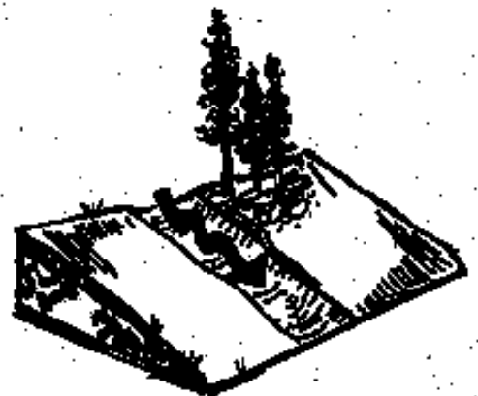

Water flowing down a hill will follow the path of least resistance, called a fall line. Trails built on the fall line will have water flowing down (rather than across) them.

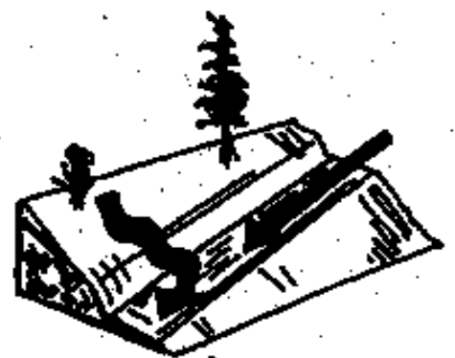
This trail does not meet the Half Rule, therefore, water will flow down the trail.
20% side slope 15% Trail Grade

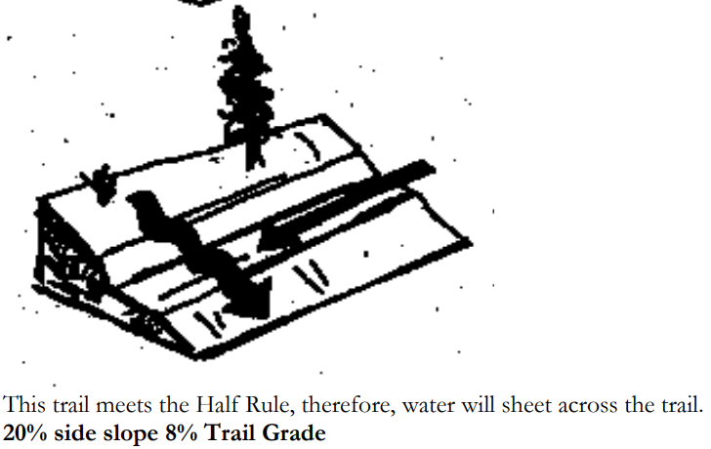

3. Out Slope
On trails that traverse hillsides, creating an out slope on the tread is a common erosion control method. This consists of a slight tilt in the tread that leaves the outside edge of the trail lower than the inside to promote drainage. This method is effective in getting water to cross or sheet the trail rather than follow it. In flat terrain, the edge of the trail should match existing grade and the trail should be crowned to drain the trail surface. Trails constructed with proper out slope still need to meet the Half Rule objective. Out slope standards are located within the standards and guidelines for trail types.
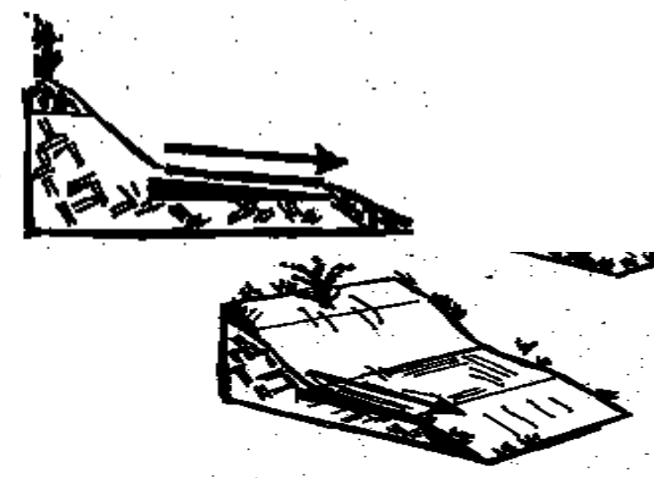

4. Switchbacks and Curves
Cross slope and curve radii are two important trail design elements that need to be considered when designing curves. During a curve, the trail briefly becomes aligned with the fall line creating the possibility of increased erosion. By building turns on a side slope of no more than 7% and building the upper part of the curve with an in slope and the lower part with an out slope you create a curve that allows water to flow across and continue down without getting captured by the trail tread. Retaining walls and armoring may also be necessary to decrease erosion and trail damage. Crowning a turn can also help mitigate erosive forces.

Curve radii are another important trail design element to be considered in turns. Larger turning radii protect user safety and help reduce erosion. A general rule of thumb is the faster a trail user is traveling, the wider the curve should be. A proper sightline before a curve is also necessary to prevent collisions or accidents. For more information refer to Trail Designations (see Section III. J.).

E. Drainage
Erosion is the natural process by which soil particles are detached from the ground surface and transported down slope by the action of moving water or wind. The combination of water falling on the trail, water running down the trail, freeze/thaw, and the wear and tear of user traffic can create significant erosion problems on trails with poor drainage. In order to create a sustainable trail with low maintenance requirements, erosion on the trail needs to be mitigated. Many preventable circumstances create a situation resulting in high erosion rates on the trail, such as trails that follow the fall line or have no out slope. Such trail design issues may result in the use of multiple drainage structures and the need for more frequent maintenance. Trail alignment, grade, design and drainage structures will help prevent water on the trail and are discussed in more detail below.

Water trapped on trails can cause erosion and damage to the trail (left). Grade breaks and out slope help direct the water off the trail (right).

Installing well-designed drainage with adequate capacity to address erosive forces is the most important element in trail design. Utilizing and protecting natural drainage patterns when aligning the trail while also constructing adequate cross slope during construction will remedy surface runoff in most situations. However, when runoff is concentrated uphill of the tread, the trail grade is steep, or a water course is likely to create drainage problems, drainage structures such as culverts, swales, drainage dips, water bars, crowning or grade breaks are required to protect the trail. The steeper the trail, the more
frequently structures are needed. The following are general guidelines for use of drainage structures.

1. Grade Breaks
Definition: Grade breaks (also called grade dips or rolling grade dips) are different from drainage dips in that they are planned and designed into the trail alignment. The drainage is created when the ascending trail gently rises, then resumes its descent.
Purpose: This reversal in trail grade creates a low point that diverts water running down the tread off the downhill side.
Trail Types: Grade breaks can be used on soft surface or natural trails.
Design: Grade breaks are most effective when they take advantage of natural features by dropping in and out of slight dips in the terrain. Grade breaks of this nature require little or no construction, other than minor grading.

Grade Break | Spacing
Spacing | Trail Grade
500’ | 3-5%
300’ | 7-10%
100’ | 11-15%
<50’ | >15%
Graph provides a general guideline of spacing between grade breaks.

2. Drainage Dips
Definition: Drainage dips are carefully shaped depressions built into an existing trail to divert water from the tread.
Purpose: Drainage dips are effective in removing rainwater and snowmelt runoff from the trail tread.
Trail Type: They should be used only on soft surface or natural trails with slight to medium grades.
Design: Drainage dips are most effective on contouring trails in which the dip drains toward the trail’s outside edge (a.k.a. positive drainage).

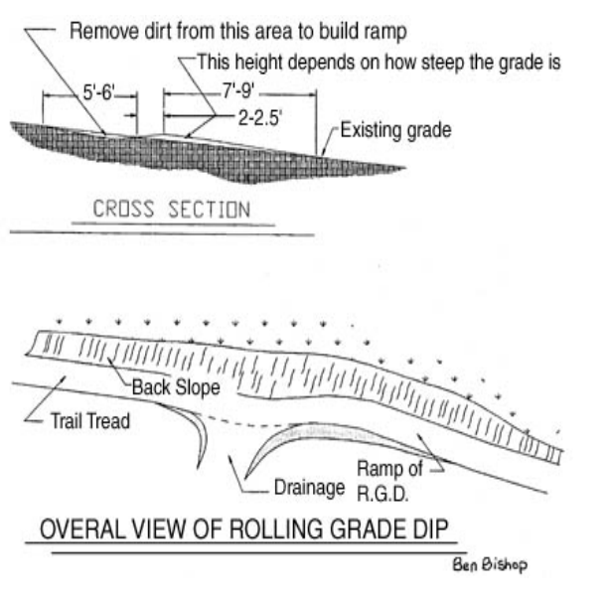

3. Water bars
Definition: A water bar is a reinforced drainage dip containing a raised row of fitted stones
or timber that helps divert runoff from the trail. Water bars are less desirable than drainage
dips and grade dips because they are jolting and may preclude some wheeled users.
Purpose: These heavy-duty structures are typically band-aid type remedies used to repair an
existing, eroded trail.
Material: Natural material such as rock or rot resistant logs is preferred but rubber barriers
are also available.
Trail Type: They should be used only on natural trails. If cyclists or wheelchairs use the
trail, the preferred alternative is a more wheel-friendly drainage dip.
Design: Waterbars should be constructed at a 30-degree angle from the trail’s edge and
should extend beyond both sides of the trail to prevent water or people from going around
them. The logs should be at least 6-8 inches in diameter and buried firmly. As the trail grade
increased (i.e., becomes steeper), the number of waterbars used should also increase.

Grade Break | Spacing Between Waterbars (feet)
2 | 250
5 | 130
10 | 80
15 | 50
20+ | 40

The above table provides a guideline when deciding on the spacing between waterbars. Some changes may be necessary for certain trail sections.

4. Armoring
Definition: Armoring is the use of large rocks to “pave” the trail to prevent erosion or protect a sensitive environment. Armoring raises the trail’s elevation while still allowing water percolation.
Purpose: Armoring is used in seasonally wet areas, or areas with accelerated erosion areas (e.g. jump landings).
Materials: When armoring, it is best to use local rock material to uphold a natural look and prevent the spread of invasive plant matter.
Trail Type: Armoring is used on natural trails.
Design: Do not remove rocks that will damage vegetation or sensitive areas. When armoring, refer to recommended practices regarding trail grade.
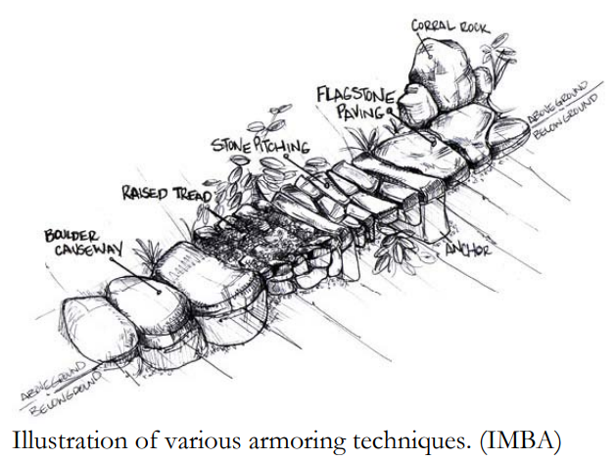

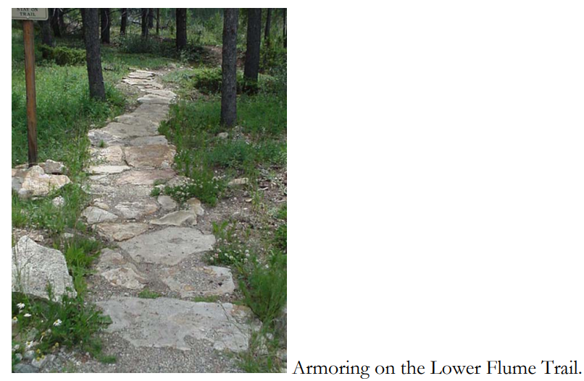

5. Culverts
Definition: A culvert is a covered channel or pipe that takes a watercourse under a trail.
Purpose: Culverts can be used to accommodate drainages that carry more than occasional storm runoff or which continue to flow after rainfall has ceased. Culverts can also be used for low flow and intermittent stream crossings, and for side swale drainage.
Trail Type: Culverts are commonly used on both hard surface pathways and soft surface trails.
Materials: A culvert is typically made of metal or plastic.
Design: Due to the complexity of culvert design, installation should be coordinated with the Town Engineering Department and the Town Trails Planner.

6. Swale Crossings
Definition: A swale crossing is a low spot in the trail that allows water to flow across the trail under controlled circumstances.
Purpose: Swale crossings are used when water flows are minimal and/or intermittent.
Trail Type: Swale crossings can be used on all trail types although they are not recommended on hard surface pathways.
Materials: On crusher fine trails, swales with minimal flows can be made with crusher fines but in areas of concentrated flow, concrete or stone paving should be used.
Design: Usually swale crossings are small and can be stepped or jumped across.

7. Side Swales
Definition: Side swales are broad, shallow ditches which parallel the trail.
Purpose: They prevent runoff water from reaching the trail surface and give water on the tread a lower place to drain.
Trail Type: Side swales can be used on all trail types.
Design: Side swales can either empty into natural drainages or be drained at intervals by culverts under the trail.
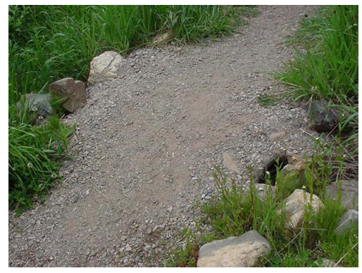

8. Crowning
Definition: Crowning is a method of trail construction where the center part of the tread is built up to allow water to run off each side.
Purpose: Crowning assists with drainage by forcing water off the trail tread.
Trail Type: This technique is most commonly used on flat soft surface and natural trails and should be used only if both sides of the trail have someplace to drain.
Design: Crowning should be steep enough to shed water, but not too steep as to cause discomfort for trail users.

III. Other Trail Considerations

A. Environmentally Sensitive and Hazardous Areas
Trails should avoid environmentally sensitive and hazardous sites whenever possible. If unavoidable, special alignment and construction methods must be used to protect the site from negative environmental impacts and provide for safety of the trail user.

The following are guidelines for constructing a trail at or near environmentally sensitive and
hazardous sites. The Town's building codes may supersede these requirements and there may be other permits necessary such as Clean Water Act permits, etc.

• Construction impacts to the area surrounding the trail should be minimized when building
a trail. When possible, trails in environmentally sensitive areas should be constructed using
hand tools. Whenever possible, the use of heavy equipment should be avoided to prevent
impacts to sensitive environments.
• The trail alignment should be planned to preserve significant vegetation.
• Plants native to the site should be used in revegetation of environmentally sensitive areas
that have been disturbed. (See the "slope stabilization, revegetation and landscaping"
section for details on revegetation.)
- Deviation from these guidelines via special alignment or construction methods may be
necessary to reduce impacts and/or disturbance to environmentally sensitive and
hazardous areas. Town staff must approve these deviations.
• Trails that cross or are located adjacent to wetlands must be designed for minimal impact.
Boardwalks or other structural techniques may be required.
• When aligning trails, the use of areas with existing disturbance such as existing social trails,
utility line easements, abandoned ditches and abandoned road cuts should be considered.
• Development of trails in areas of critical wildlife and plant habitat may require site-specific
studies to determine impacts, mitigation, and appropriate alignments.
• In order to protect environmentally sensitive areas during and after trail construction,
erosion control methods such as siltation fences and straw bale barriers may be required.
Revegetation may also be required.

B. Winter Trails
In most cases, Town trails will be used in both summer and winter. Winter trail use will be primarily oriented toward on-snow usage such as Nordic skiing or snowshoeing. When locating trails that can support winter use consider:
• Aligning trails to take advantage of opportunities for shade and wind protection (i.e.,
locating in northern exposures and maximizing shading from evergreens).
• Avoiding conflicts with roadside snow storage by placing trails a minimum setback of 20 feet from any road to be plowed during winter.
• Widening the trail corridor to provide for a safer and more enjoyable winter travel corridor.
• Installing additional signage that is high enough to be visible during winter and far enough away from plowed routes to also ensure winter visibility. Blue diamond markers are typically used to mark winter travel routes.

As trails used for Nordic skiing become steeper, the minimum horizontal clearance should increase. This increased width does not need to be cleared of all vegetation but should provide skiers a wide area for turning, “herring boning” and snowplowing when the trail is snow covered. Steep Nordic ski trails may need to provide gently sloped clearings and runouts for skiers to slow down, particularly at switchbacks.

In general, winter trails to be plowed to accommodate heavy use should be hard surface pathways. Soft surface and natural surface trails with design features that cannot support plowing equipment will not be plowed. Where the potential for groomed and developed winter trail systems exists (such as Nordic centers), wider easements, or separate trails, may be necessary to accommodate both groomed trails and other public use.

C. Existing Trails
The Town of Blue River contains many existing trails. Most fit into the natural trail category. Few, if any, design considerations were applied during their development. Consequently, most existing trails meet few of the standards recommended in this document.

As trails of this nature become Town easements, it may be necessary to bring the trail up to the standards listed in this document, from a usability, safety, and maintenance perspective as well as to minimize liability to the Town. However, the Town recognizes that bringing an existing trail up to current standards is not always possible or desirable. In reviewing proposals for trail projects, the Town Staff shall have the discretion to exempt certain trails from standards that are not possible to meet based on the existing condition of the trail. Armoring or other trail building techniques may be necessary to address such concerns.

If an existing trail must be realigned, the new trail should, when appropriate, duplicate or improve the original trail's standards and character as much as possible.

D. Trails with Universal Access
Trails should be designed, particularly hard surface pathways in the more heavily populated areas of Town, to accommodate access by the physically disabled. A trail should not exceed a 5% grade where access by physically disabled users is possible. In addition, special design considerations (such as modified drainage structures) should be incorporated. Due to mountainous conditions, some hard surface pathways may not be accessible to the entire spectrum of physically disabled users. While it is clearly not practical for all trails in a mountain community to be fully accessible to the disabled, the Town will make every effort to comply with the standards set forth in the Americans with Disabilities Act of 1992 (ADA) and in the American Association of State Highway Transportation Officials (AASHTO) bike and pedestrian trail guidelines, where reasonably appropriate. Most natural trails and some soft surface trails are not expected to comply with ADA or may be identified as acceptable for only a more advanced level of physically disabled user.

E. Wetlands and Water Crossings
When dealing with riparian environments, special precautions need to be made in order to mitigate or prevent sedimentation and damage to sensitive ecosystems. Preventing and minimizing impacts to wetland areas is critical to aquatic health and, in relation to trails, can often be accomplished by minimizing vegetation removal and soil disturbance. If construction on stream banks, lakes, shores, and wetlands is unavoidable, the trail tread should be raised using turnpikes, boardwalks, or armoring. To avoid water quality impacts from chemical leaching from treated wood, structures should be constructed with natural untreated wood, precast concrete, or steel. If the wood is pretreated, the structure should be isolated in poly wrap below grade. If trails enter wetland areas, permits may be required, and the U.S. Army Corps of Engineers should be contacted.

F. Slope Stabilization, Revegetation and Landscaping
Revegetation is important to control erosion and stabilize slopes, as well as to improve aesthetics. It is important that revegetation be sensitive to existing on-site plant species in order to maintain a natural character and balance. The most important areas for revegetation are where major disturbance occurs, usually related to hard surface pathways. Another disturbance area of concern is related to cut and fill slopes or full bench cuts on steeply sloping sites (over 30%). Town staff must be consulted regarding all revegetation plans.
The following guidelines should be followed in all cases.
• Care should be taken to maintain existing vegetation (including the understory) wherever possible.
• Plantings should consist of low maintenance, drought resistant, and native species.
• On-site native plant species should be identified, and revegetation should occur with an appropriate mixture of these native plants if possible. This is especially important in environmentally sensitive areas.
• Non-native plant species or standard high-altitude seed mix should not be used where such revegetation would promote invasion by introduced species that are not found on site and which would have an adverse effect on native plants. This is especially important in environmentally sensitive areas.
• In environmentally sensitive areas it may be best not to plant anything but instead to simply prepare and mulch the seedbed with a seed-free erosion control/mulch blanket.
• In areas of minimal disturbance and with sparse under story vegetation (lodgepole pine forests), revegetation may not be necessary, but excavated soils should be widely dispersed away from the corridor.
• The type of plants and the formality of plantings should complement the natural and man-made plantings around the site and neighborhood. The trail corridor should either seem like part of a native ecosystem or part of an adjacent landscaped area.
• Revegetation should occur as soon as grading work is completed and weather permits. Revegetated sites should be maintained until enough establishment has occurred to reasonably stabilize the site.

The following guidelines should be followed where there is major disturbance:
• Temporary slope stabilization and revegetation will be necessary during construction,
and until permanent drainage and successful revegetation is achieved.
• Landscaping may be necessary to recreate natural character, minimize visual impact or
to create a buffer between the trail and adjacent uses. Landscaping recommendations in
the Town Development Code and Town of Blue River Noxious Weed Management Plan (2021) should be followed.

G. Structures
Structures are trail corridor improvements necessary for user comfort or to solve specific drainage, grading, safety, and water crossing situations. For public safety and economy, most structures should be designed by a design professional. Trail structures should complement the character of the surrounding landscape. Typical structures related to trail development are retaining walls, bridges, boardwalks, turnpikes, fences, steps, stairways, railings, and other user amenities such as restrooms and benches. Some structures have already been discussed in the Drainage section of this appendix.

1. Retaining Walls
Definition: A retaining wall is a vertical structure usually consisting of rock or timber that enables construction of a trail around obstacles, stabilization and widening of trail sections and stabilization of trails on loose soil.
Purpose: Retaining walls are often used to reduce erosion on cut and fill slopes when slopes exceed a stable angle. In addition, retaining walls may be necessary to reduce the size of a cut and fill, or minimize disturbance on an environmentally or visually sensitive site. The Town Staff should be involved during the design and construction of retaining walls.
Materials: Whenever possible, natural materials should be used in wall construction such as rock or wood. To decrease long term maintenance, rock is preferred.
Design: Walls located in visually sensitive areas should be designed to blend with the surroundings. Retaining walls should not be too continuous, thereby avoiding a channelized feeling. The wall should tilt into the slope. An inward tilt of 1 foot for every 4 feet of height is the maximum recommendation with a ratio of 2:1 being more typical and acceptable.
Trail Type: To avoid both the "engineered" look and abrupt drop-off sometimes created by retaining walls, they should be used only in select circumstances (especially when developing soft surface, natural or rough trails).

2. Bridges
Purpose: Bridges are used to cross a natural or man-made drainage that has a year-round flow and to span a ravine or gully-type terrain feature.
Trail Type: Bridges should be used to cross a perennial stream where a water crossing would create hazardous conditions or damage to the environment.
Materials: Whenever possible, natural materials should be used.
Design: Bridges should be designed to withstand floods and should be placed to avoid sharp curves or deflections. Bridge width should be able to accommodate the largest trail use such as bikes, horses, or pedestrian. Emergency access or maintenance vehicles may also need to be considered in the design phase.

On most bridges, the minimum width should be the same as the approach trail plus the horizontal clearance. An exception to this would be a simple bridge on a pedestrian-only soft surface, natural or rough trail. On hard surface pathways and multi-use soft surface trails, bridges should be 2 to 4 feet wider than the approaching trail. Railings may be required where the distance from the ground is 30 inches or more (see "railings" for additional details). Bumpers and ramps may also be required on trail-based bridges. On natural and rough trails, with small streams that can be stepped over during normal flow, a bridge may not be necessary. In this case refer to the section on armoring. Where bridges are necessary on these trails, design should be simple and incorporate use of native materials, when possible. Bridges must be approved by the Town Staff and in many cases will have to be designed by a civil engineer.

Tips For Successful Bridge Building:
1) Make bridges strong enough to support the heaviest potential user and snow loads
2) For wooden bridges choose a material that is rot resistant. Bark must be stripped off the logs to prevent rot and insect damage
3) For wooden bridges, use screws or bolts, not nails
4) Extend approach ramps onto the trail
5) Avoid letting bridge stringers touch the ground. Sit stringers on stones or replaceable wood
6) Bridges and their approaches should not have sharp turns; this can be dangerous when icy or wet
7) Design the bridge so that travelers can see each other on either end

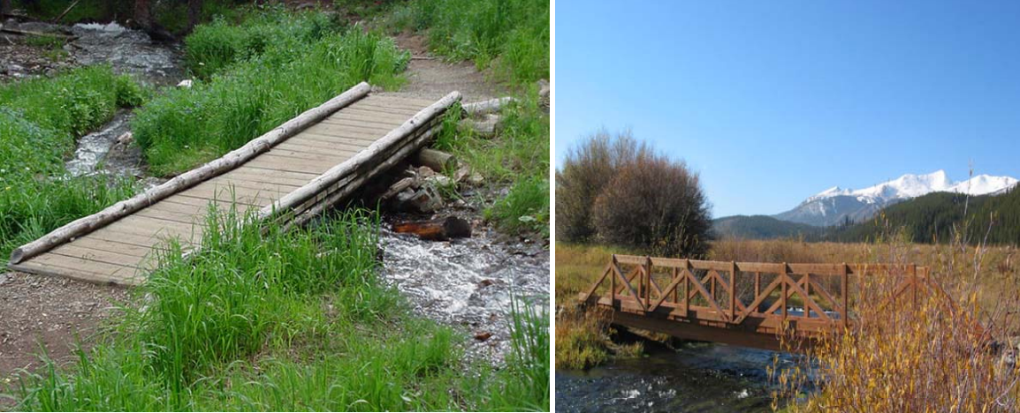

3. Boardwalks
Definition: Boardwalks are elevated structures usually of wood or recycled plastic that can be used to minimize environmental impact when crossing over or traveling adjacent to wetlands or occasionally flooded areas.
Purpose: Boardwalks are designed to span wet or boggy areas.
Materials: All wood used in boardwalk construction should be pressure treated or a rot resistant timber. Boardwalk decking can also be comprised of recycled plastic materials.
Design: The bottom of the stringers of a boardwalk should be above high-water levels. The design of the boardwalk should avoid interference with the flow of floodwater and floating debris. In most situations it is better to build as little as possible that will have to resist the force of high-velocity floodwaters. See "guidelines for environmentally sensitive areas" for details on building trails near or through wet areas.

4. Turnpikes
Definition: Turnpikes (also called causeways) are raised trail treads that typically consist of logs or rocks embedded along the sides of the trail to hold fill material (e.g. gravel and crusher fines) in place.
Purpose: The intent of a turnpike is to carry soft surface, natural or rough trails above short sections of seasonally damp and marshy ground, which is saturated with water in spring but remains dry for most of the year.
Materials: A layer of geotextile fabric should be placed between the fill material and damp ground to prevent subsidence of the trail.
Design: A turnpike should have a 1 to 2-inch crown and shallow side swales to facilitate drainage. The turnpike should not alter water flows in ways that disturb nearby ecosystems and should not be used to cross wetlands where surface water is present.

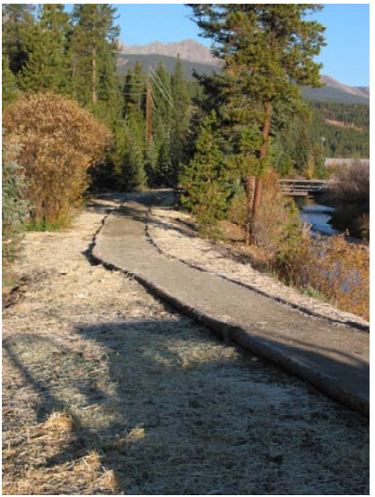

5. Fences
Purpose: Fences should be installed only when physical separation is necessary for safety and/or to preserve adjacent landowner privacy.
Design: Where possible, fencing should be located only on one side of the trail at a time. Fencing designs which create a narrow corridor effect for long stretches should be avoided. Whenever possible, fences should be no closer than 5 feet from the trail edge. Where fences are necessary along both sides of a trail, minimum width should be 20 feet between the two sections of fence. Fencing should be compatible with wildlife migration patterns.
Materials: Whenever possible, natural materials should be used.

6. Steps or Stairs
Purpose: Steps can be used on sections of trail where elevation must be gained quickly, usually in areas where the grade exceeds the recommended maximum.
Design: Where steps are located on steep grades, a handrail may be required on one or both sides to provide for safety and user comfort (see "railings" for additional details). When stairs are located in the more urban areas of Town, design should comply with Town building codes.
Trail Types: Steps are not recommended for trails used by horses, bikes and the disabled.
Materials: Stone is preferred for steps, however, treated timber can also be used.
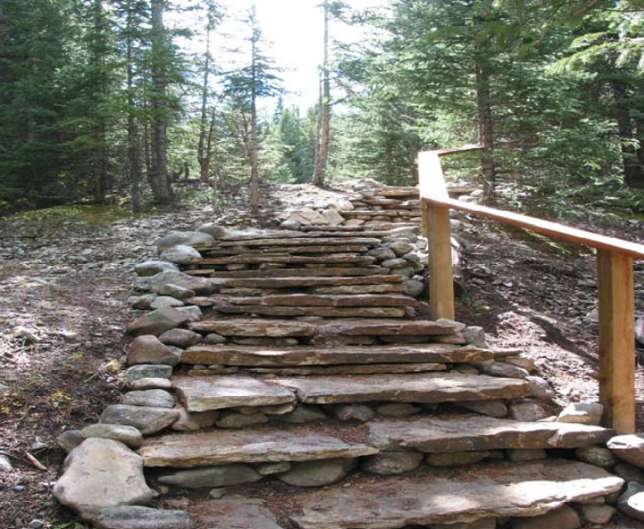

7. Railings
Purpose: Railings are recommended on high volume, hard surface pathways and soft surface trails where a steep drop off exists within 5 feet of the trail edge.
Purpose: Railings can be used on trails as necessary for user safety and comfort.
Materials: Whenever possible, natural materials should be used.
Design: Railings on pedestrian trails should be 42 inches high. Railings on multi-use hard surface pathways which receive considerable use by bicyclists should be 54 inches high. For general use in mixed bicycle/pedestrian situations and in zones which are not high-speed bike zones, 42 inch railings are preferred. Railing ends should be flared away from the trail at either end of the railing. Where railings are used on trails located in the more developed areas of Town, design should comply with Town building codes.

H. Trailheads and Signage
Signage at the trailhead and throughout the trail should be used to inform and educate trail users. Properly located signs can be an indicator of location, distance, property boundaries or restricted uses, preventing unwanted conflicts, or confusion. Listed below are some objectives for trail signage. Town staff must approve all signs.

• Signs should be consistent with those used throughout the Town.
• Signs should be legible; this includes typography, vocabulary, and other design elements.
• Signs should inform users of the trail’s use types, direction, location of the trail, location of private property, or other information that can assist and inform trail users.
• Signs should be low maintenance and be capable of withstanding extreme weather conditions and abuse.
• Signs should not obstruct the trail or natural scenery. Informational signs can be grouped together at the trailhead while warning signs should be located to give trail users a chance to react.
• Over use of signs can diminish the natural effect while under use can leave the trail user confused.
• Rot resistant wood or stone should be used to maintain the most natural appearance.

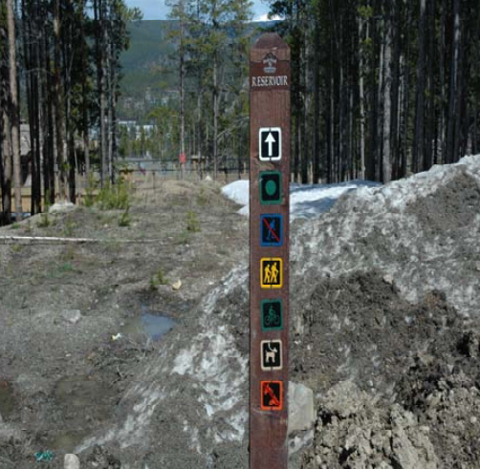

I. Intersections
Intersections should be highly visible and provide good sight distance, clear zones, and proper signage. Accommodation of enough stopping sight distance at roadway intersections is critical and adequate warning should be given to permit trail users to stop before reaching the intersection, especially on downgrades. On high volume trail/vehicular intersections, a flat approach grade is especially important and appropriate striping and regulatory signage may be necessary. In less developed areas containing low volume soft surface or natural trails, less formal intersections may be possible (depending on the volume of traffic) and signage may not be necessary. The appropriate road management department or agency should be contacted regarding trail/road intersections. Their involvement at the design phase may be necessary. Whenever possible, a 90-degree intersection is preferable to one with a lesser angle.

J. Trail Designations
1. Hard Surface
Definition: A primary characteristic of a hard surface trail is its inability to absorb water. Material for such a trail may include concrete, asphalt, cement, or crushed stone.
Uses: A major use of hard surface trails is to easily accommodate handicap accessibility and heavy use. Paved trails, such as bike paths or recpaths, should be used to link trails, residential areas and the center of town to accommodate recreationists as well as commuters.
Materials: Asphalt is preferred due to its flexible qualities and ability to accommodate the expansion and contraction of soils cause by severe temperature changes that occur in Blue River.
Standards: Hard surface trails should be well designed, well-constructed, and properly maintained. The following chart is a guideline when building a hard surface trail. Changes may be necessary to accommodate natural obstacles, sensitive areas, or historical amenities.

Hard Surface Trails
Spacing Between Waterbars (feet)
Width | 8'-12'
Surface | Asphalt is preferred
Grade | 6% or less is preferred
Radius | Refer to AASHTO guidelines
Sight Distance | 75' or more
Easement Width | 20'-25' minimum
Side Slope | less than 12%, no more than 15%
Vertical Clearance | 12'
Horizontal Clearance | at least 2' from side of tread
Cross Slope | 2% minimum

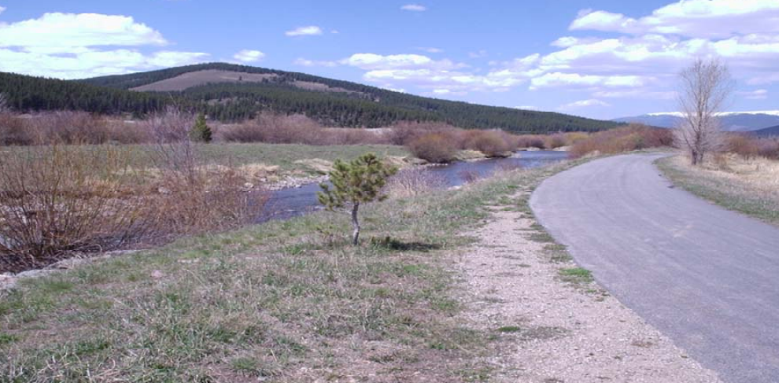

2. Soft Surface
Definition: Soft surface trails have a high permeability rate and consists of an applied surface such as crusher fines or road base.
Uses: This tread is intended to be more rural than a paved pathway. Soft surface trails can accommodate single track, trails in rural areas, and link to larger trails or points of interest.
Materials: Crusher fines or road base.
Standards: Soft surface trails require less preparation than hard surface trails. Constructing a soft surface trail requires the removal of sub grade obstacles such as roots and rocks, the incorporation of proper drainage structures, and the placement of a geotextile fabric t prevent the placed fill material from sinking. These trails should be well designed, well-constructed, and properly maintained. The following chart is a guideline when building a soft surface trail. Changes may be necessary to accommodate natural obstacles, sensitive areas, or historical amenities.

Soft Surface Trails
Spacing Between Waterbars (feet)
Width | 4’ minimum
Surface | Crusher fine and road base
Grade | 3-5% preferred; 8% maximum
Radius | 20’ minimum
Sight Distance | 75' minimum
Easement Width | 15’ minimum
Side Slope | Less than 12% preferred; 15% maximum
Vertical Clearance | 10'
Horizontal Clearance | 36”-48” from either side of the tread
Cross Slope | 2% minimum

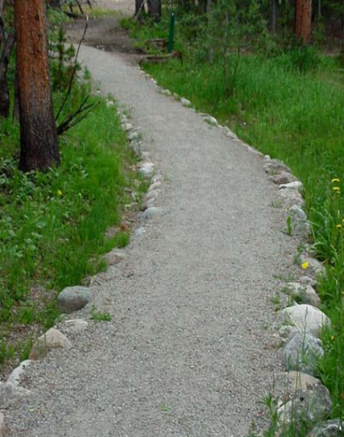

3. Natural Surface
Definition: Natural surface trails (a.k.a. backcountry or rough trails) should provide access to open space, neighborhoods, and other trails. They are usually located in less developed areas, should blend with their surroundings, and should require little maintenance with only a few drainage structures.
Uses: Natural surface trails can accommodate mountain bikers, equestrians, and pedestrians.
Materials: Mineral soil and other earthen materials.
Standards: Natural surface trails should be designed at grade to minimize erosion. Sections of grades over 12% may be unavoidable but should be short and should never exceed 20%. These trails should be well designed, well-constructed, and properly maintained. The following chart is a guideline when building a natural surface trail. Changes may be necessary to accommodate natural obstacles, sensitive areas, or historical amenities.

Natural Surface Trails
Spacing Between Waterbars (feet)
Width | 18” minimum
Surface | Mineral Soil
Grade | 8% or less preferred; 20% maximum
Radius | 4’ minimum
Sight Distance | 50' minimum
Easement Width | 15’ minimum
Slope | Less than 30% preferred; 70% maximum
Vertical Clearance | 10'
Horizontal Clearance | Minimum 1 ft from either side of the tread
Cross Slope | 3% minimum

C – Open Space and Trails Master Plan Map

